OOP-LAB Task 7

Roll No: 24P-0706 | Dept: BS-CS
Name: Aazan Noor Khuwaja | Section : 2D

QNS-1:
#include<iostream>
using namespace std;

class room {
int room_no;
public:
room(int r = 0) : room_no(r) {} // Default value needed
int show_room() {
return room_no;
}
};

class doctor {
int id;
string name;
string specialization; // spelling fixed
room r1;
public:
doctor() : id(0), name(""), specialization(""), r1(0) {} // Default constructor needed
doctor(int i, string n, string spec, int ro) : id(i), name(n), specialization(spec), r1(ro) {}

string get_name() {
return name;
}
string get_specialization() {
return specialization;
}
friend void doctor_details(doctor doc);
};

void doctor_details(doctor doc) {
cout << "Doctor Id: " << doc.id << endl;
cout << "Doctor Name: " << doc.name << endl;
cout << "Doctor Specialization: " << doc.specialization << endl;
cout << "Doctor Room No: " << doc.r1.show_room() << endl;
}

class patient {
int pat_id;
string pat_name;
string pat_disease;
doctor* d1;
public:
patient() : pat_id(0), pat_name(""), pat_disease(""), d1(nullptr) {}
patient(int i, string n, string d, doctor* doct) : pat_id(i), pat_name(n), pat_disease(d), d1(doct) {}

friend void show_patient(patient p1);
};

void show_patient(patient p1) {
cout << "Patient Id: " << p1.pat_id << endl;
cout << "Patient Name: " << p1.pat_name << endl;
cout << "Patient Disease: " << p1.pat_disease << endl;
cout << "Doctor Name: " << p1.d1->get_name() << endl;
cout << "Doctor Specialization: " << p1.d1->get_specialization() << endl;
cout << endl;
}

class hospital {
public:
patient p1[10];
doctor d1[10];
int doc_count;
int pat_count;

hospital() : doc_count(0), pat_count(0) {}

void printHospitalInfo() {
cout << "Hospital Patients Information:" << endl;
for (int i = 0; i < pat_count; i++) {
show_patient(p1[i]);
}
}

void show_doctor_details() {
cout << "Hospital Doctors Information" << endl;
for (int i = 0; i < doc_count; i++) {
doctor_details(d1[i]);
}
}
};

int main() {
hospital h;
h.d1[0] = doctor(1, "Dr. Ghulam Nabi", "MBBS GYNO", 101);
h.d1[1] = doctor(2, "Dr. Qasim Jan", "Neurologist", 102);
h.doc_count = 2;
h.p1[0] = patient(1, "Azan", "Heart Disease", &h.d1[0]);
h.p1[1] = patient(2, "Aslam", "Brain Tumor", &h.d1[1]);
h.pat_count = 2;
h.show_doctor_details();
cout << endl;
h.printHospitalInfo();

return 0;
}

Output: 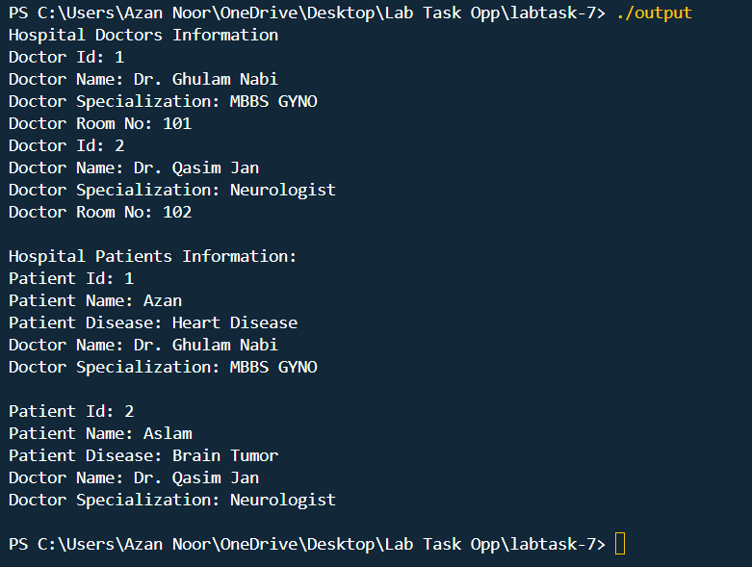

QNS-2:
Code:
#include<iostream>
#include<string>
using namespace std;

class Professor {
string professor_name;
int employee_id;
public:
Professor(string name, int id) : professor_name(name), employee_id(id) {}

void display_professor() {
cout << "Professor Name: " << professor_name << ", Employee ID: " << employee_id << endl;
}
};

class Student;

class Course {
string course_title;
string course_code;
Professor* prof;
Student* students[30];
int student_count;
string hidden_notes;
float course_stars;

public:
Course(string title, string code, Professor* p) : course_title(title), course_code(code), prof(p), student_count(0) {
hidden_notes = "Internal: Focus on research papers.";
course_stars = 4.6;
}

void assign_professor(Professor* p) {
prof = p;
}

void enroll_student(Student* s) {
if (student_count < 30) {
students[student_count++] = s;
}
}

void show_course() {
cout << "Course Title: " << course_title << ", Course Code: " << course_code << endl;
if (prof != nullptr) {
prof->display_professor();
} else {
cout << "No Professor assigned yet.\n";
}
cout << "Total Students Enrolled: " << student_count << endl;
}

friend class Student;
};

class Student {
string student_name;
int roll_number;

public:
Student(string name, int roll) : student_name(name), roll_number(roll) {}

void view_course_details(Course &c) {
cout << "\nStudent View" << endl;
cout << "Course Title: " << c.course_title << ", Course Code: " << c.course_code << endl;
cout << "Internal Notes: " << c.hidden_notes << endl;
cout << "Course Rating: " << c.course_stars << " stars" << endl;
}
};

int main() {
Professor prof1("Dr. Sarah", 501);
Professor prof2("Dr. Malik", 502);

Course course1("Data Structures", "CS201", &prof1);
Course course2("Database Systems", "CS301", &prof2);

Student student1("Alice", 1001);
Student student2("Bob", 1002);

course1.enroll_student(&student1);
course1.enroll_student(&student2);

course2.enroll_student(&student1);

cout << "Course 1 Details:" << endl;
course1.show_course();

cout << "\nCourse 2 Details:" << endl;
course2.show_course();
cout << "\nStudent Accessing Course Details:" << endl;
student1.view_course_details(course1);
student2.view_course_details(course2);

return 0;
}

Output:
